Development cooperation: power supplies on RiLineX
Rittal and PULS enter into a technology partnership
Herborn/Munich, 2026-03-03
Promoting plant engineering with greater efficiency and speed: That is the aim of the new technology partnership between Rittal and PULS, concluded at the SPS trade fair in Nuremberg in November 2025. Together, the two companies are developing innovations for the European and international markets that significantly speed up plant engineering. The combination of Rittal’s RiLineX, as the new standard platform for busbar systems, and market-leading power supplies from PULS provides the platform.
This partnership brings together two technology leaders in their respective fields for joint development projects: Rittal as the world’s leading supplier of enclosure systems and PULS as the market and technology leader in industrial power supply solutions. This makes PULS the first technology partner of the RiLineX standard platform’s Power Supplies function group.

“We are delighted to have found a top manufacturer of industrial power supply solutions in PULS. It ideally complements the Rittal product range centred around RiLineX with its innovative power packs and high level of technical expertise,” says Raphael Görner, Executive Vice President, Energy & Power Solutions at Rittal. With RiLineX, Rittal is setting a new standard for power distribution technology in mechanical and plant engineering. By using our highly efficient PULS power supplies, we are expanding the platform’s benefits to ensure even more efficient plant construction for our joint customers,” adds Bernhard Erdl, CEO and founder of PULS.
Most PULS power supply units are mounted and wired on the DIN rail. In the future, the company will also offer options with special mechanical modifications that can be contacted directly on the RiLineX board. In the future plant constructors will have significant advantages by reducing the space required on the busbar, install low-maintenance power supplies with 97% efficiency without using tools, and do so faster and more easily, so significantly reducing wiring costs. This is real added value, especially during periods of skilled labour shortages. Much less engineering effort is required when planning 60-mm busbar systems, which are often complex for plant constructors. Speed is of the essence, particularly in growing fields such as building technology or battery energy storage systems (BESS).
The first products from the partnership are expected to be presented during 2026. The development of power supplies across different power-output classes is also planned. Visitors will be able to see a first practical example from 8 March at Light + Building, Stand B80, in Frankfurt/Main: Highly efficient PULS power packs contact the RiLineX board directly and can be installed quickly and without tools.

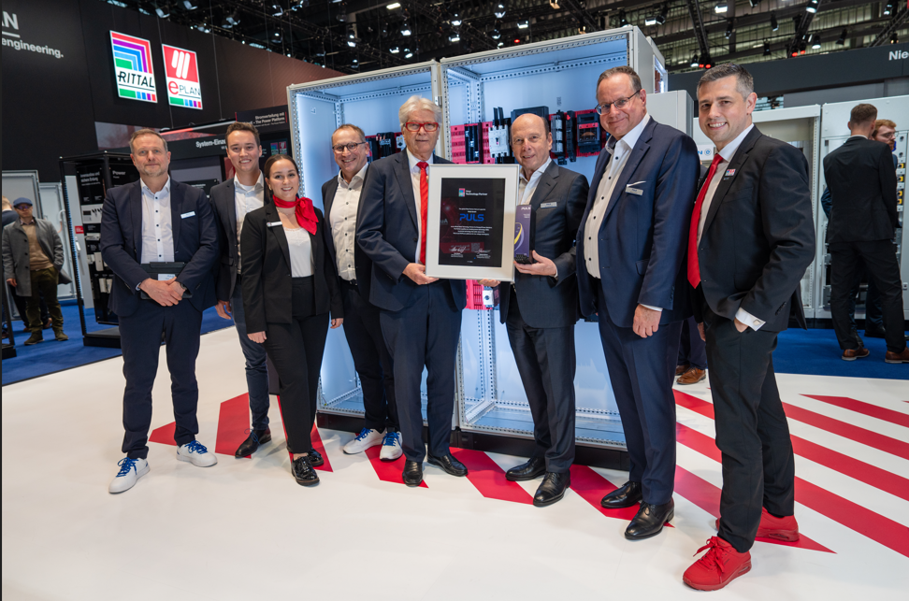
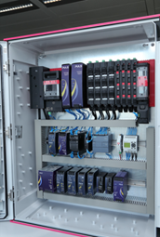

Caption Image 1  Alliance for a more competitive mechanical and plant engineering sector. Rittal and Puls seal their partnership at SPS 2025 in Nuremberg. |  | Caption Image 2  Highly efficient PULS power packs contact the RiLineX board directly and can be installed quickly and without tools.  .

May be reproduced free of charge. Please name Rittal GmbH & Co. KG as the source
PULS:
The PULS Group, founded in 1980 by Bernhard Erdl in Munich, is a globally leading provider of industrial DC power supply solutions. Its portfolio includes highly efficient DIN rail power supplies, decentralised IP54, IP65 and IP67 field power supplies and reliable DC UPS systems. With the acquisition of Adelsystem, PULS has strengthened its expertise in uninterrupted power supply. In the wireless charging segment, the PULS business unit Wiferion is setting the standard for inductive charging systems used in AGVs and mobile robots.
PULS employs around 1,400 people and operates its own production sites in Europe and Asia.

Rittal
Rittal is a leading global supplier of enclosure systems, automation and infrastructure with its industrial, IT, energy and power, cooling and service units. Rittal products and solutions are used in over 90% of global industries – standardised, customised, and always of the very best quality.

Our approach and methodology: Rittal, Rittal Software Systems (Eplan, Cideon) and Rittal Automation Systems (RAS, Ehrt, Alfra) combine their hardware and software expertise to streamline, optimise and industiralise processes across the entire value chain of their customers including their IT infrastructure – from control and switchgear construction, machine building to manufacturing companies or the energy sector.

Our delivery promise: Rittal standard products are delivered in Germany within 24 hours, and within 48 hours throughout Europe.
Focus on the customer
Improving efficiency and increasing productivity through automation and digitalisation is one of the biggest challenges for our customers. This requires in-depth knowledge and expertise, the combination of hardware and software, and cross-sector networking. We are convinced that creating and connecting data rooms is crucial to the success of industrial transformation. And that is exactly our speciality and field of competence.

Eplan and Rittal are driving the development of the digital automation twin, making data accessible and useable in operations as well. Cideon is improving data consistency in the digital product twin context with its CAD/CAM, PDM/PLM and product configuration expertise.
Sustainability
Environmental and climate protection, social commitment and ethical corporate management are a given for Rittal. We take our responsibility for a sustainable future seriously. Our approach to resource management and conservation involves continuous improvement of our own production processes and ensuring that our products have the lowest possible Product Carbon Footprint. Our solutions support our customers in achieving their own climate targets.
Family business and global player
Founded in 1961, Rittal is the largest company in the owner-operated Friedhelm Loh Group. The group operates worldwide, with 13 production sites and 95 international subsidiaries. It has 12,600 employees and posted revenues of 3.1 billion euros in fiscal 2024. In 2023, the Friedhelm Loh Group was presented with the “Best Place to Learn” and “Employer of the Future” awards. In 2025, Rittal was awarded the Top 100 Seal as one of Germany’s most innovative medium-sized companies for the fourth time in a row. In 2025, the Rittal plant in Haiger won overall first place in the independent and highly-prestigious “Factory of the Year” competition, which recognised it as a hallmark of manufacturing excellence and one of the very best factories in Europe.

For more information, visit www.rittal.com and www.friedhelm-loh-group.com.

Corporate & Brand Communications

Hans-Robert Koch Steffen Maltzan
Phone: +49 2772/ 505 2693 Phone: +49 2772 505 2680
E-mail: koch.hr@rittal.de E-mail: maltzan.s@rittal.de

Rittal GmbH & Co. KG, Auf dem Stützelberg, 35745 Herborn, Germany
www.rittal.com

